title

CAMBRIA, 20pt ,bold, center

no indent (heading 1)

for papers written in the Russian language, also write AND English title

Prof. Name and surname, title

Prof. Name and surname, title

Prof. Name and surname, title

Times New Roman, bold, 11pt, center, no indent, spacing: before 6pt, after 6pt
Abstract: Abstract should be written according to instructions given: maximum 300 words, font Times New Roman 11 pt, italic, justify. After the Abstract, use the same style for Keywords and JEL classification. Abstract should be submitted to the e-mail office@aqss.rs with a note Abstract, until 01/09/2026. (Title style Abstract). For papers written in russian language,abstract should be written in english too.
Keywords: Keyword 1, Keyword 2, Keyword 3, Keyword 4, Keyword 5 (maximum 5 keywords) Times New Roman 10 pt, italic; For papers written in russian language,keyword should be written in english too
JEL Classification: use the system provided at http://www.aeaweb.org/jel/jel_class_system.php, Times New Roman 10pt, italic

INTRODUCTION (times new roman 12pt, all caps, bold) style: heading 2
Articles should be written in English or Russian, typed in MS Office Word (. doc /. docx) (font: Times New Roman 12pt, justify, paragraph spacing: before 6 pt, line spacing: single (Style: Text). Suggested paper length is 6 - 10 pages, paper size A4 (210 x 297 mm), all margins set at 20 mm. Header and footer 12.7 mm. papers should be written in a single column, adhering to these guidelines. A maximum of THREE authors per paper is allowed.

Second level heading (Times New Roman, 12pt, bold, paragraph spacing: before 6pt, after 6pt) Style: Heading 3

Citation rules
The first citation of a book, article, document contains full information about the author (s), work, editor (editor, editor), publisher, place of publication, year of publication and page from which the part or idea was taken::
EXAMPLE: Santos, G., Mendes, F. and Barbosa, J., Certification and Integration of Management Systems: The Experience of Portuguese Small and Medium Enterprises.” Journal of Cleaner Production, Vol. 19, No. 17, 2011, pp. 1965-74
The citation of the article can be in regular or italic letters or under quotation marks
The literature cited in the footnotes must also be found in the bibliography
In each subsequent appearance, the surname and the initial of the name are stated, “op. cit., ”or op. cit., and page number (s):
EXAMPLE: Santos, G., Mendes, F. and Barbosa, ., op. cit., pg. 9.
If it is the same author, the same work and the same page as in the previous footnote can be placed like this:
EXAMPLE: Ibid.
If the same work is cited as in the previous footnote but from a different page after the abbreviation Ibid, specify the page number and put a full stop:
EXAMPLE: Ibid., 521.
When there are several authors in the footnote, all are listed in the order in which they are listed in the article or book that is cited. If there are more than 3 of them, the first author and indication can be stated, etc. or et al
EXAMPLE Santos, J., et al., Certification and Integration of Management Systems: The Experience of Portuguese Small and Medium Enterprises.” Journal of Cleaner Production, Vol. 19, No. 17, 2011, pp. 1965-74
Citing the article in the footnote: author's surname, initial, title of the work, journal, number, ie volume and number, year of publication, number of the first and last page, (abbreviation p. Or p. And pp.58).
EXAMPLE Petrovic N., Drakulic M., Vujin V., Drakulic R., Jeremic V., Climate changes and green information technologies, Management, no 59/2011, pp. 35–45.
When it comes to an article downloaded from the Internet, in addition to all the usual information, the web address from which it was "downloaded" is stated, as well as the date of access..

The third level heading ( Times New Roman, 12 pt, italic, paragraph spacing: before 6pt, after 6pt) Style: Heading 4

PICTURES
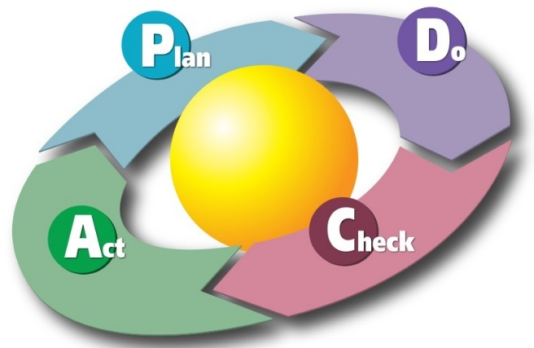
Each picture should be numbered in ascending order starting with number 1. Figure caption should be written below the image, centered, in Times New Roman 10 pt, bold, italic
Picture 1. Title of picture (Style: Slike)
Source: Source name, year, country

tabLE
Tables should be numbered in ascending order starting with number 1. Table caption should be written above the table, left, Times New Roman, bold, italic, spacing before 6pt, 6pt after.
Table 1.Times New Roman, 10 pt, bold, italic , left
Column 1 | Column 2 | Column 3
Row 1 | Row 1 | Row 1
Row 2 | Row 2 | Row 2
Row 3 | Row 3 | Row 3
Row 4 | Row 4 | Row 4
Source: Source name, year, country

LIST
When enumerating by items use the following style
- Item 1 (Bullet 1)
- Item 2
  - Sub-item 1 (Bullet 2)
  - Sub-item 2
- Item 3
- Item 4
When enumerating by numbers using the following style
- Text 1 (style: Numbering 1)
- Text 2
- Text 3
LITERATURE: TIMES NEW ROMAN, 11PT, BOLD, ALL CAPS
Literature should be written in the Harvard style. List of literature mention the end of the article by following instructions
- Books: author’s last name, first letter of the author’s name, (year of publication) title of the book, place of publication, publisher
- Magazines: author’s last name, first letter of the author’s name (year of publication), title of the paper, name of the magazine, issue number, page

Name and surname, Institution, City, Country, e-mail
Name and surname, Institution, City, Country, e-mail
Name and surname, Institution, City, Country, e-mail
Santos, G., Mendes, F. and Barbosa, J., Certification and Integration of Management Systems: The Experience of Portuguese Small and Medium Enterprises.” Journal of Cleaner Production, Vol. 19, No. 17, 2011, pp. 1965-74
Ibid, 18

